**EX 3 SIMPLE TCP/IP CLIENT SERVER COMMUNICATION**

**Aim:** To establish communication between the Client and the Server to exchange messages

**Algorithm:**

1. An object of ***ServerSocket*** is instantiated, and desired port number is specified, on which connection is going to take place.
2. The ***accept*** method of ***ServerSocket*** is invoked, in order to hold the server in listening mode. This method won’t resume until a client is connected to the server through the given port number.
3. Now, on client side, an object of ***Socket*** is instantiated, and desired port number and IP address is specified for the connection.
4. An attempt is made, for connecting the client to the server using the specified IP address and port number. If attempt is successful, client is provided with a ***Socket*** that is capable of communicating to the respective server, with write and read methods. If unsuccessful, the desired exception is raised.
5. Since a client is connected to the server, ***accept*** method on the server side resumes, providing a ***Socket*** that is capable of communicating to the connected client.
6. Once the communication is completed, terminate the sockets on both, the server and the client side.

**Steps for execution:**

1. Open the command prompt and set path for java.

set path="C:\Program Files\Java\jdk1.8.0_202\bin"

The command to check whether the path is set or not : javac

1. Open Notepad and type the client program and save the filename as class name(MyClient) for Client program [Ex:MyClient.java] . Similarly open another Notepad and type Server program and save the file name as server class name(MyServer) for Server [Ex: MyServer.java].
2. For Server: open cmd

To Compile:

javac File_name.java

To Run:

java File_name

1. For Client: open cmd

To Compile:

javac File_name.java

To Run:

java File_name

**Server Program (MyServer.java)**

import java.io.*;

import java.net.*;

public class MyServer {

public static void main(String[] args){

try{

ServerSocket ss=new ServerSocket(6666);

System.out.println("Server is on..... Listening...... ");

Socket s=ss.accept();//establishes connection

DataInputStream dis=new DataInputStream(s.getInputStream());

String  str=(String)dis.readUTF();

System.out.println("message= "+str);

ss.close();

}catch(Exception e){System.out.println(e);

}

}

}

**Client Program (MyClient.java)**

import java.io.*;

import java.net.*;

public class MyClient {

public static void main(String[] args) {

try{

Socket s=new Socket("localhost",6666);

DataOutputStream dout=new DataOutputStream(s.getOutputStream());

dout.writeUTF("Hello Server");

dout.flush();

dout.close();

s.close();

}catch(Exception e){System.out.println(e);}

}

}

**Output**

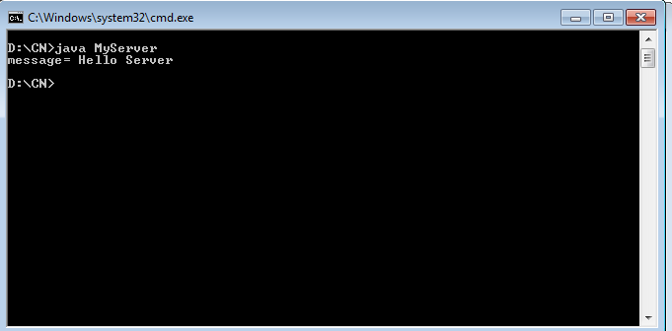  
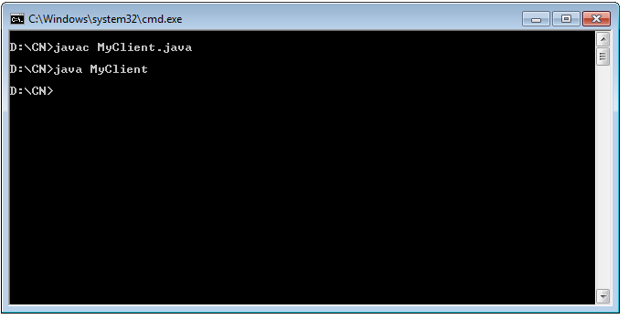

**RESULT:**  Thus the communication between the Client and the Server to exchange messages has been established